Breast Cancer Detection Machine Learning Project Report

**1. Introduction:**

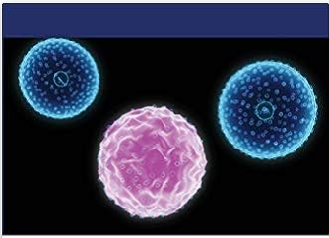

Breast cancer is one of the most prevalent types of cancer among women worldwide. Early detection and accurate diagnosis are crucial for effective treatment and improved patient outcomes.

In this machine learning project, our aim is to develop a breast cancer detection system that can accurately classify whether a person is suffering from breast cancer or not based on various features extracted from medical imaging data.

**2. Data Description:**

For this project, we utilized a dataset containing medical imaging data of mean radius , diagnostic reports . The dataset includes a total of 569 instances, each with 31 features. The dataset comprises both cancer- positive and cancer-negative cases, enabling the development of a balanced and accurate predictive model.

Each data point in this dataset represents a set of features that are used to classify whether a breast tumor is malignant (cancerous) or benign (non-cancerous).

Let's briefly describe each of the features:

1. Mean Radius:

The average distance from the center to points on the perimeter of the tumor. It gives an indication of the tumor size.

**2. Mean Texture:**

The average variation in gray-scale intensities of the pixels in the image, which provides information about the smoothness of the tumor's boundaries.

**3. Mean Perimeter:**

The average size of the tumor's boundary.

**4. Mean Area:**

The average area enclosed by the tumor's boundary.

**5. Mean Smoothness:**

A measure of the local variation in radius lengths, which indicates how smooth the tumor is.

**6. Mean Compactness:**

A measure of how closely the tumor is compacted, calculated as the perimeter squared divided by the area. It gives information about the tumor's shape.

**7. Mean Concavity:**

The average severity of concave portions of the tumor's contour, providing insights into the presence of concave regions.

**8. Mean Concave Points:**

The average number of concave portions of the tumor's contour, indicating the presence of concave regions.

**9. Mean Symmetry:**

A measure of the symmetry of the tumor's contour.

**10. Mean Fractal Dimension:**

A measure of the roughness of the tumor's contour.

**11. Worst Texture:**

Similar to the mean texture, but representing the worst (largest) value of texture for each cell nucleus.

**12. Worst Perimeter:**

Similar to the mean perimeter, but representing the worst (largest) value of perimeter for each cell nucleus.

**13. Worst Area:**

Similar to the mean area, but representing the worst (largest) value of area for each cell nucleus.

**14. Worst Smoothness:**

Similar to the mean smoothness, but representing the worst (lowest) value of smoothness for each cell nucleus.

**15. Worst Compactness:**

Similar to the mean compactness, but representing the worst (largest) value of compactness for each cell nucleus.

**16. Worst Concavity:**

Similar to the mean concavity, but representing the worst (largest) value of concavity for each cell nucleus.

**17. Worst Concave Points:**

Similar to the mean concave points, but representing the worst (largest) value of concave points for each cell nucleus.

**18. Worst Symmetry:**

Similar to the mean symmetry, but representing the worst (largest) value of symmetry for each cell nucleus.

**19. Worst Fractal Dimension:**

Similar to the mean fractal dimension, but representing the worst (largest) value of fractal dimension for each cell nucleus.

**20. Target:**

The target variable with values 0 and 1, where 0 represents a benign tumor and 1 represents a malignant tumor. This is the label we want to predict based on the given features.

**3.Methodology:**

Our approach to building the breast cancer detection system involves the following steps:

1. **Data Preprocessing:**
2. **Missing Value Handling:** We checked for missing values and either removed the corresponding instances or imputed the missing values using appropriate methods.
3. **Feature Scaling:** To ensure uniformity among features, we performed feature scaling to bring them to a similar range.
4. **Feature Selection:** We used relevant feature selection techniques to identify the most informative features and remove any irrelevant or redundant ones.
5. Model Selection: We experimented with various machine learning algorithms to find the best-performing model for breast cancer detection. The algorithms considered include but are not limited to:

* Support Vector Classifier
* Logistic Regression
* K-Nearest neighbour classifier
* Naive Bayes classifier
* Decision Tree classifier
* Random Forest classifier
* Adaboost classifier
* Xgboost classifier

c. Model Training:

* We split the dataset into training and testing sets (typically using an 80-20 split).
* The training set was used to train the chosen machine learning model on the breast cancer dataset, while the testing set was used to evaluate the model's performance.

d. Model Evaluation:

To evaluate the performance of the developed model, we used various evaluation metrics, including:

* Accuracy: To measure the overall correctness of the predictions.
* Precision: To measure the proportion of true positive predictions out of the total positive predictions.
* Recall: To measure the proportion of true positive predictions out of the actual positive instances.
* F1 Score: The harmonic mean of precision and recall, providing a balanced evaluation metric.

4. Results:

After training and evaluating the different models, we identified the best-performing algorithm with its corresponding hyperparameters. The selected model demonstrated high accuracy, precision, recall, and F1 score, indicating its effectiveness in detecting breast cancer from medical imaging data.

1. Accuracy:

The Highest Accuracy is 0.9824561403508771 given by XGboost model.

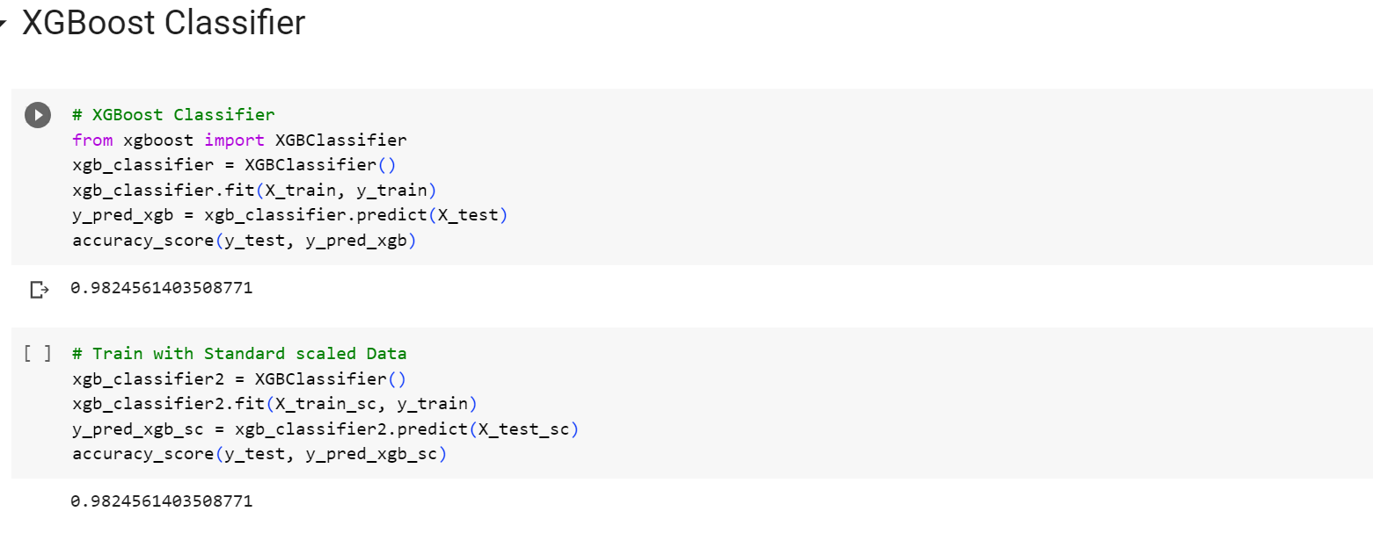

5. Conclusion:

The breast cancer detection machine learning project successfully developed a reliable and accurate system for identifying whether a person is suffering from breast cancer or not based on medical imaging data.

Early detection through this system could potentially lead to more timely and effective treatments, improving the chances of recovery for patients.

6. Future Enhancements:

To further improve the system, we suggest exploring the following enhancements:

* Incorporating more advanced feature extraction techniques from medical images.
* Utilizing deep learning models and transfer learning for enhanced performance.
* Expanding the dataset to include more diverse samples for improved generalization.
* Collaborating with healthcare professionals to ensure the model's real-world usability and validation.

7. Acknowledgment:

I would like to acknowledge the creators of the dataset used in this project, as well as the open-source machine learning libraries that facilitated the implementation of various algorithms and specially thanks to LearnWik that helps me to gain some experience while doing this project.

8. References:

## [***https://scikit-learn.org/stable/***](https://scikit-learn.org/stable/)

## [***https://www.w3schools.com/python/pandas/default.asp***](https://www.w3schools.com/python/pandas/default.asp)

[***https://www.w3schools.com/python/matplotlib_intro.asp***](https://www.w3schools.com/python/matplotlib_intro.asp)

***https://www.w3schools.com/python/numpy/default.asp***